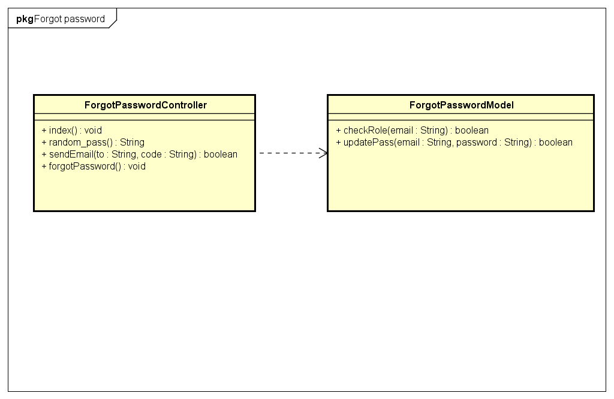

|  |  |  |  |
| --- | --- | --- | --- |
| **ForgotPasswordControllers** | | | |
| **Physical address** | admin/application/controllers | | |
| **Base class** |  | | |
| **Attributes** | | | |
| N/A | | | |
| **Operations** | | | |
| index() | | | |
| **Return Type** | void | | |
| **Parameters** | N/A | | |
| random_pass() | | | |
| **Return Type** | String | | |
| **Parameters** | N/A | | |
| sendEmail() | | | |
| **Return Type** | boolean | | |
| **Parameters** | **Name** | **Type** | **Description** |
|  | To | String | User email to receive email |
|  | code | String | New Password for user |

|  |  |  |  |
| --- | --- | --- | --- |
| **ForgotPasswordModel** | | | |
| **Physical address** | admin/application/models | | |
| **Base class** |  | | |
| **Attributes** | | | |
| N/A | | | |
| **Operations** | | | |
| checkRole() | | | |
| **Return type** | boolean | | |
| **Parameters** | **Name** | **Type** | **Description** |
|  | email | String | The user email |
| UpdatePass() | | | |
| **Return type** | Array | | |
| **Parameters** | **Name** | **Type** | **Description** |
|  | email | String | The user email |
|  | password | String | New password |